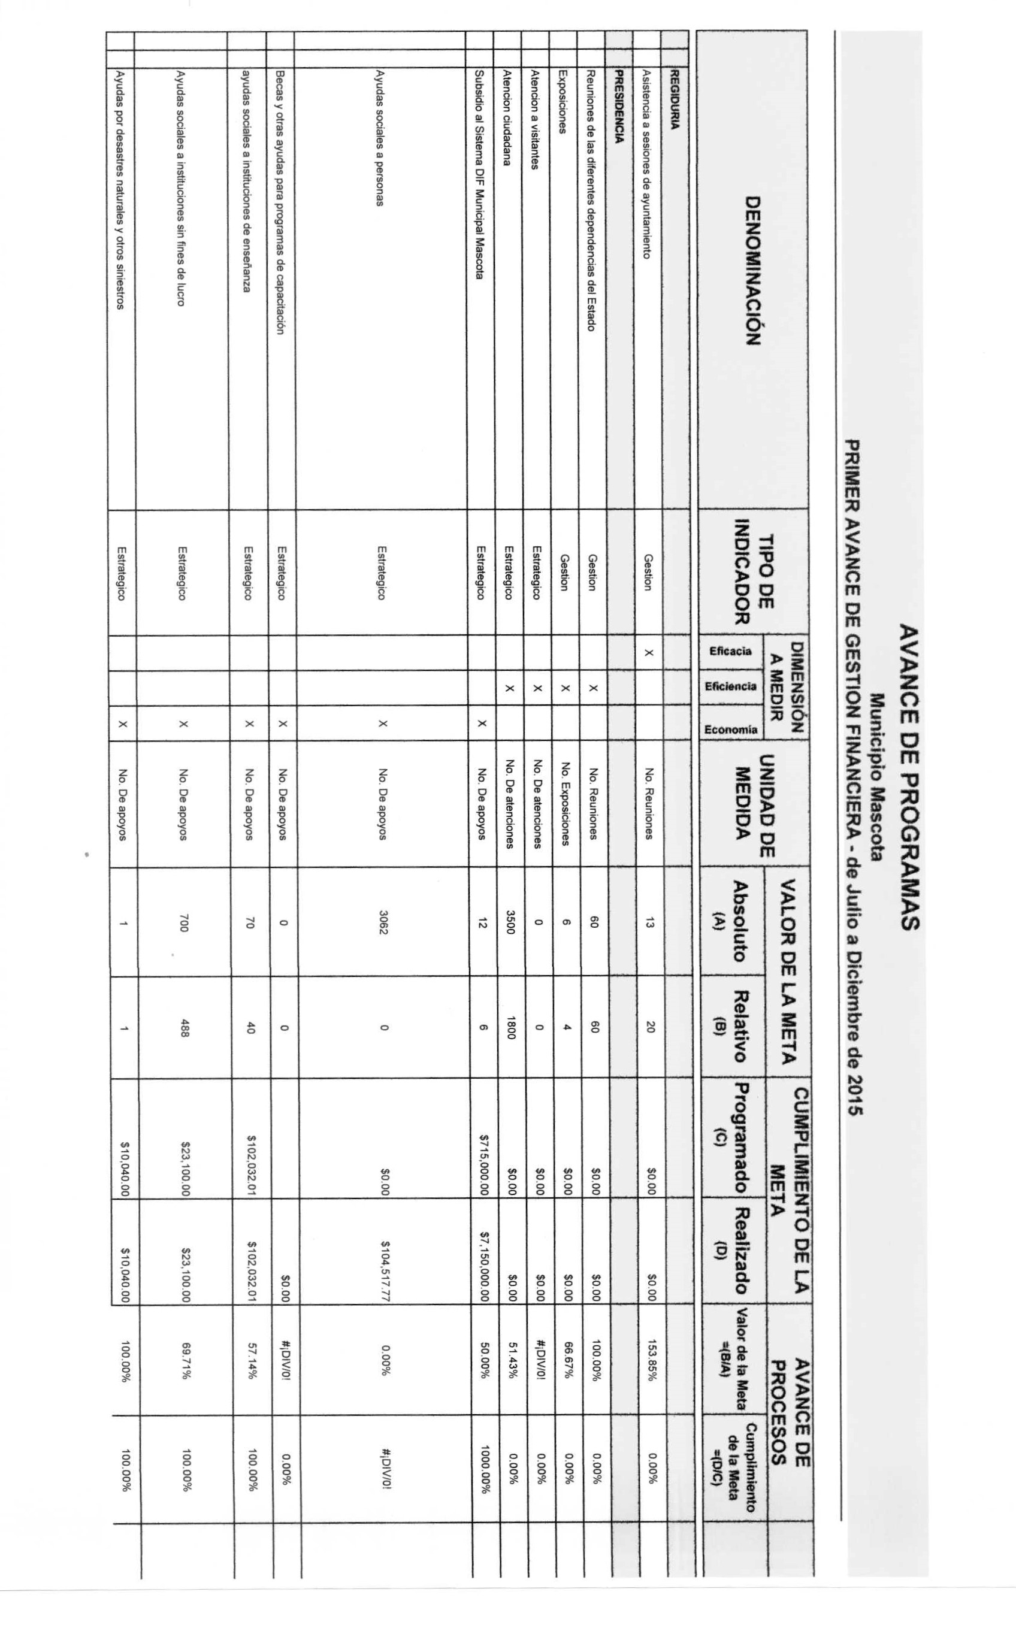
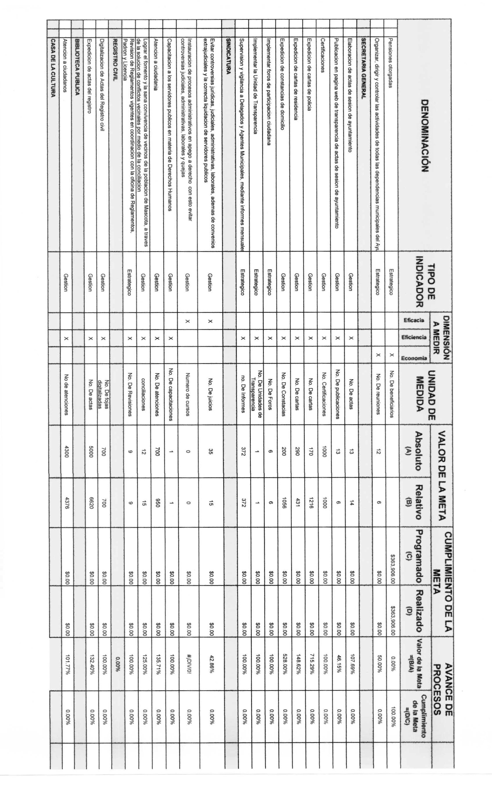
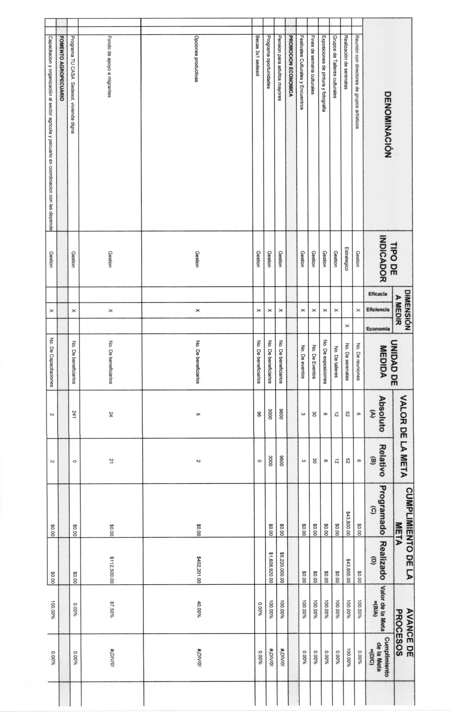
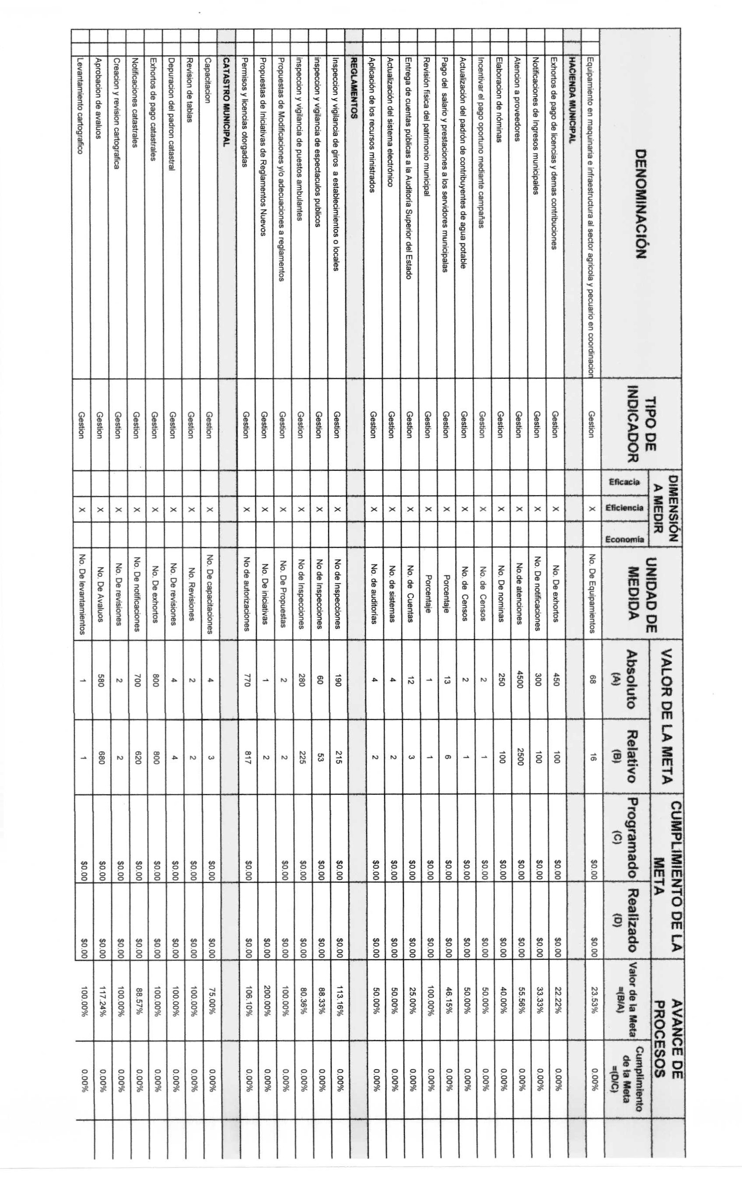
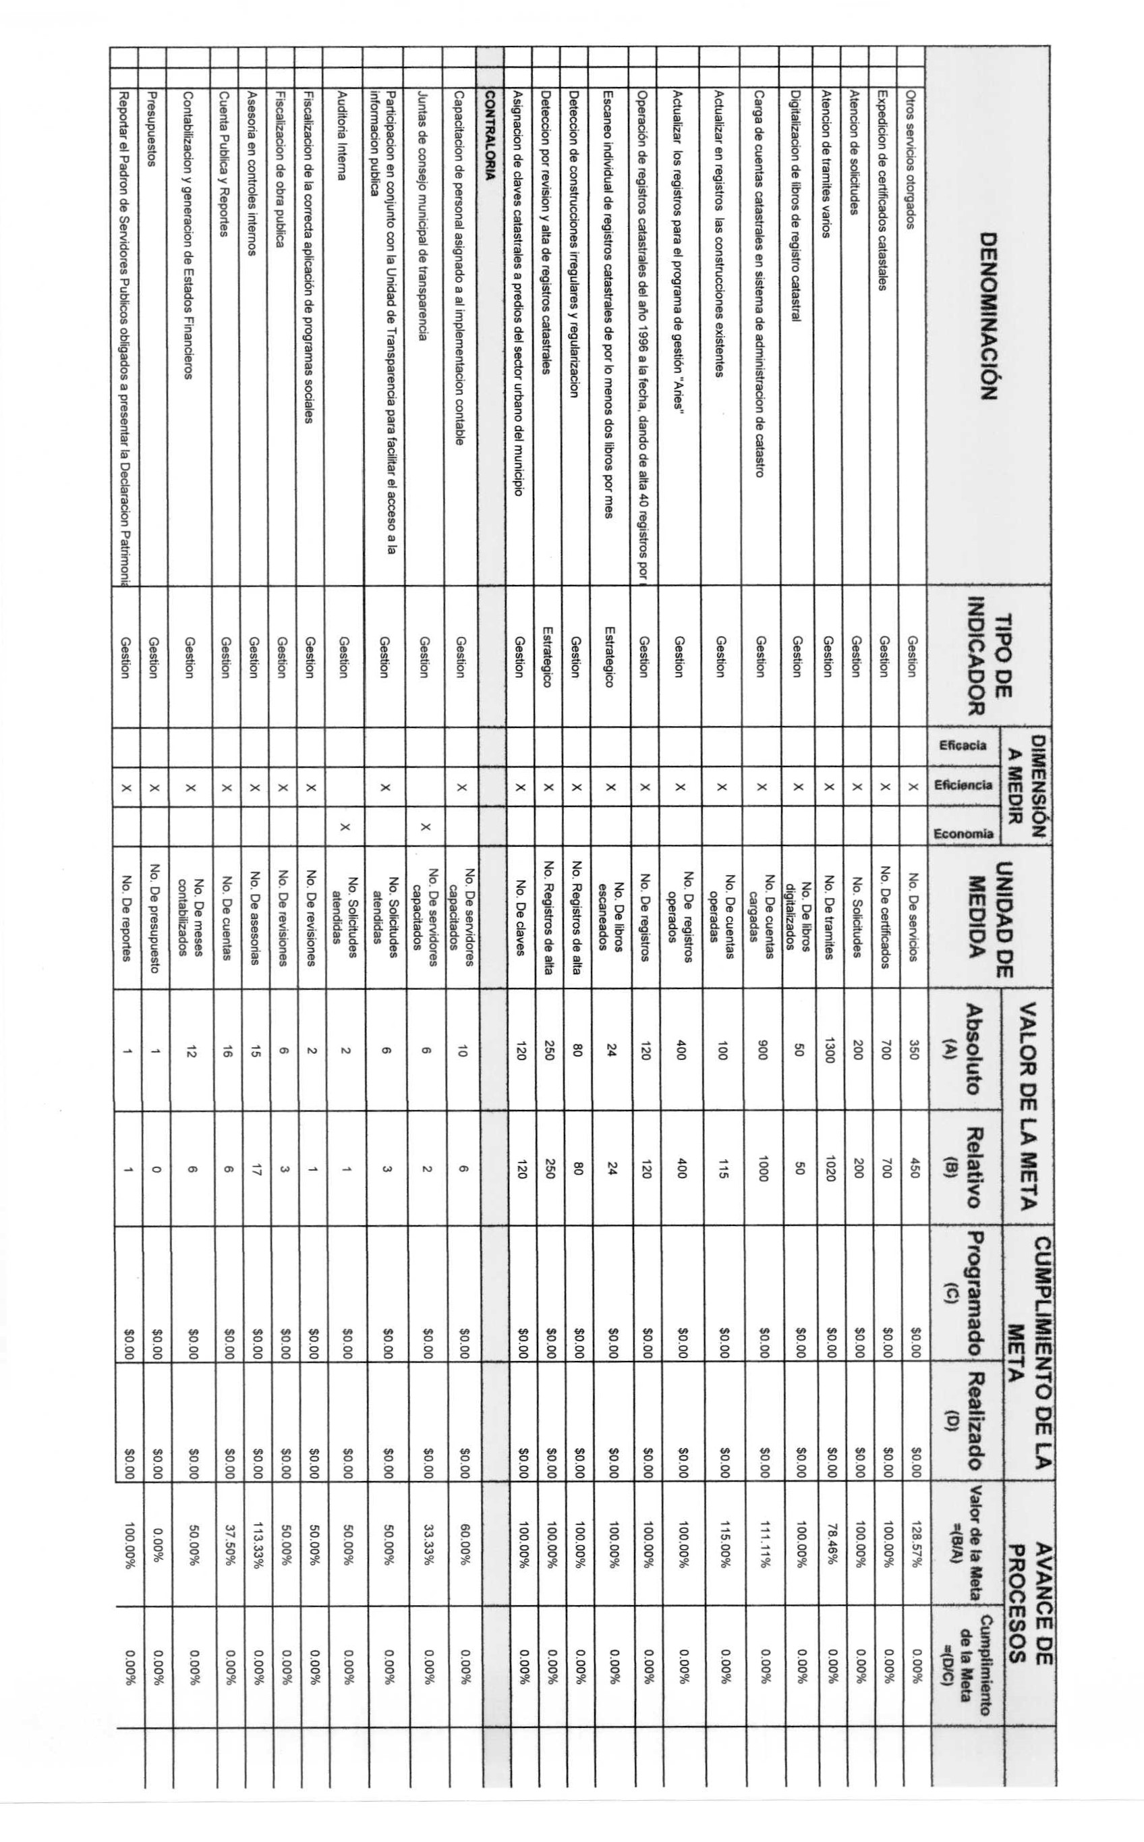

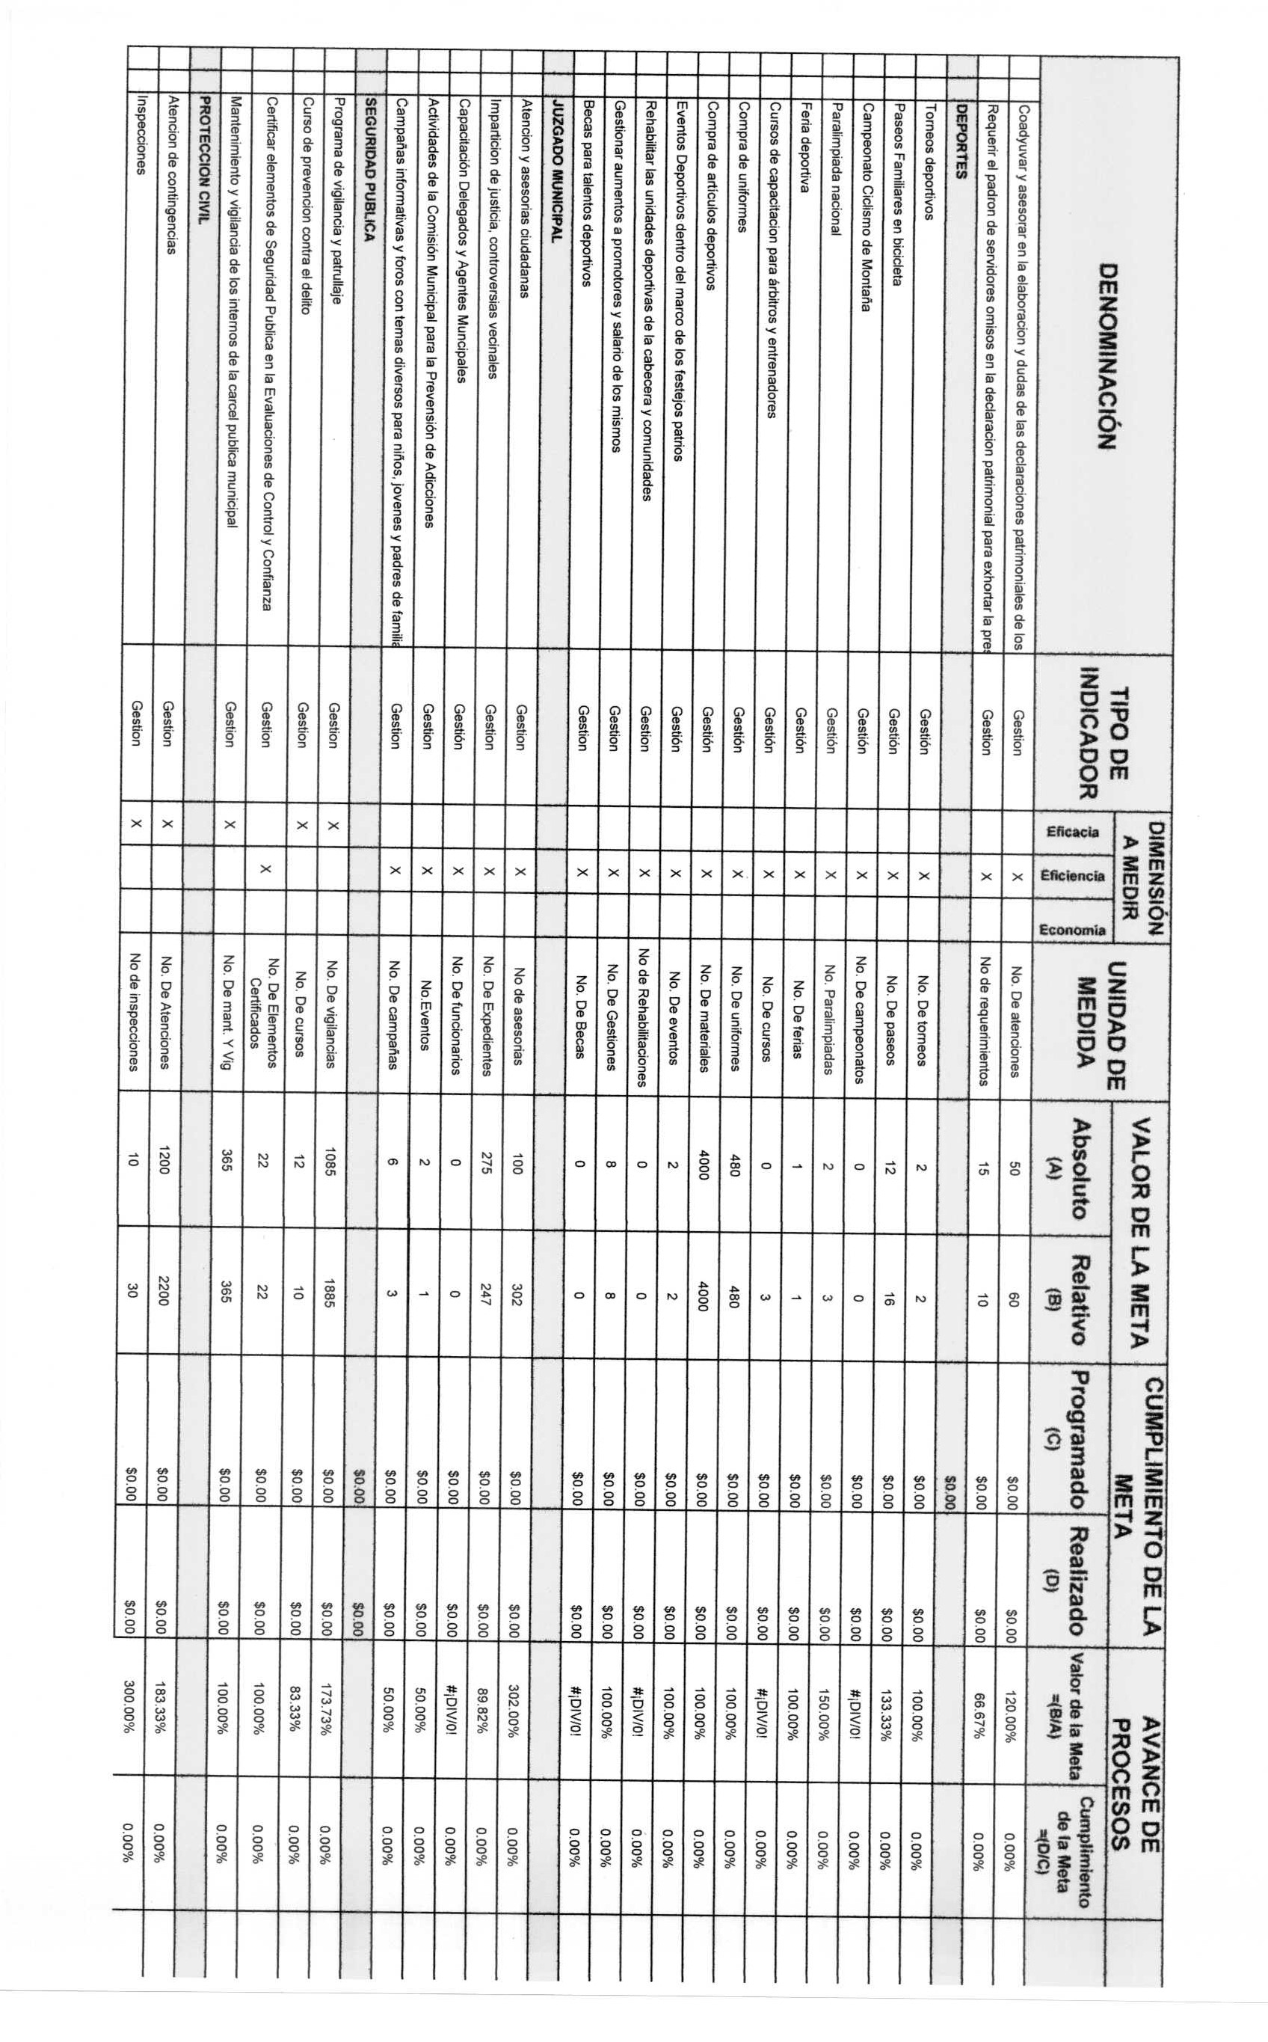

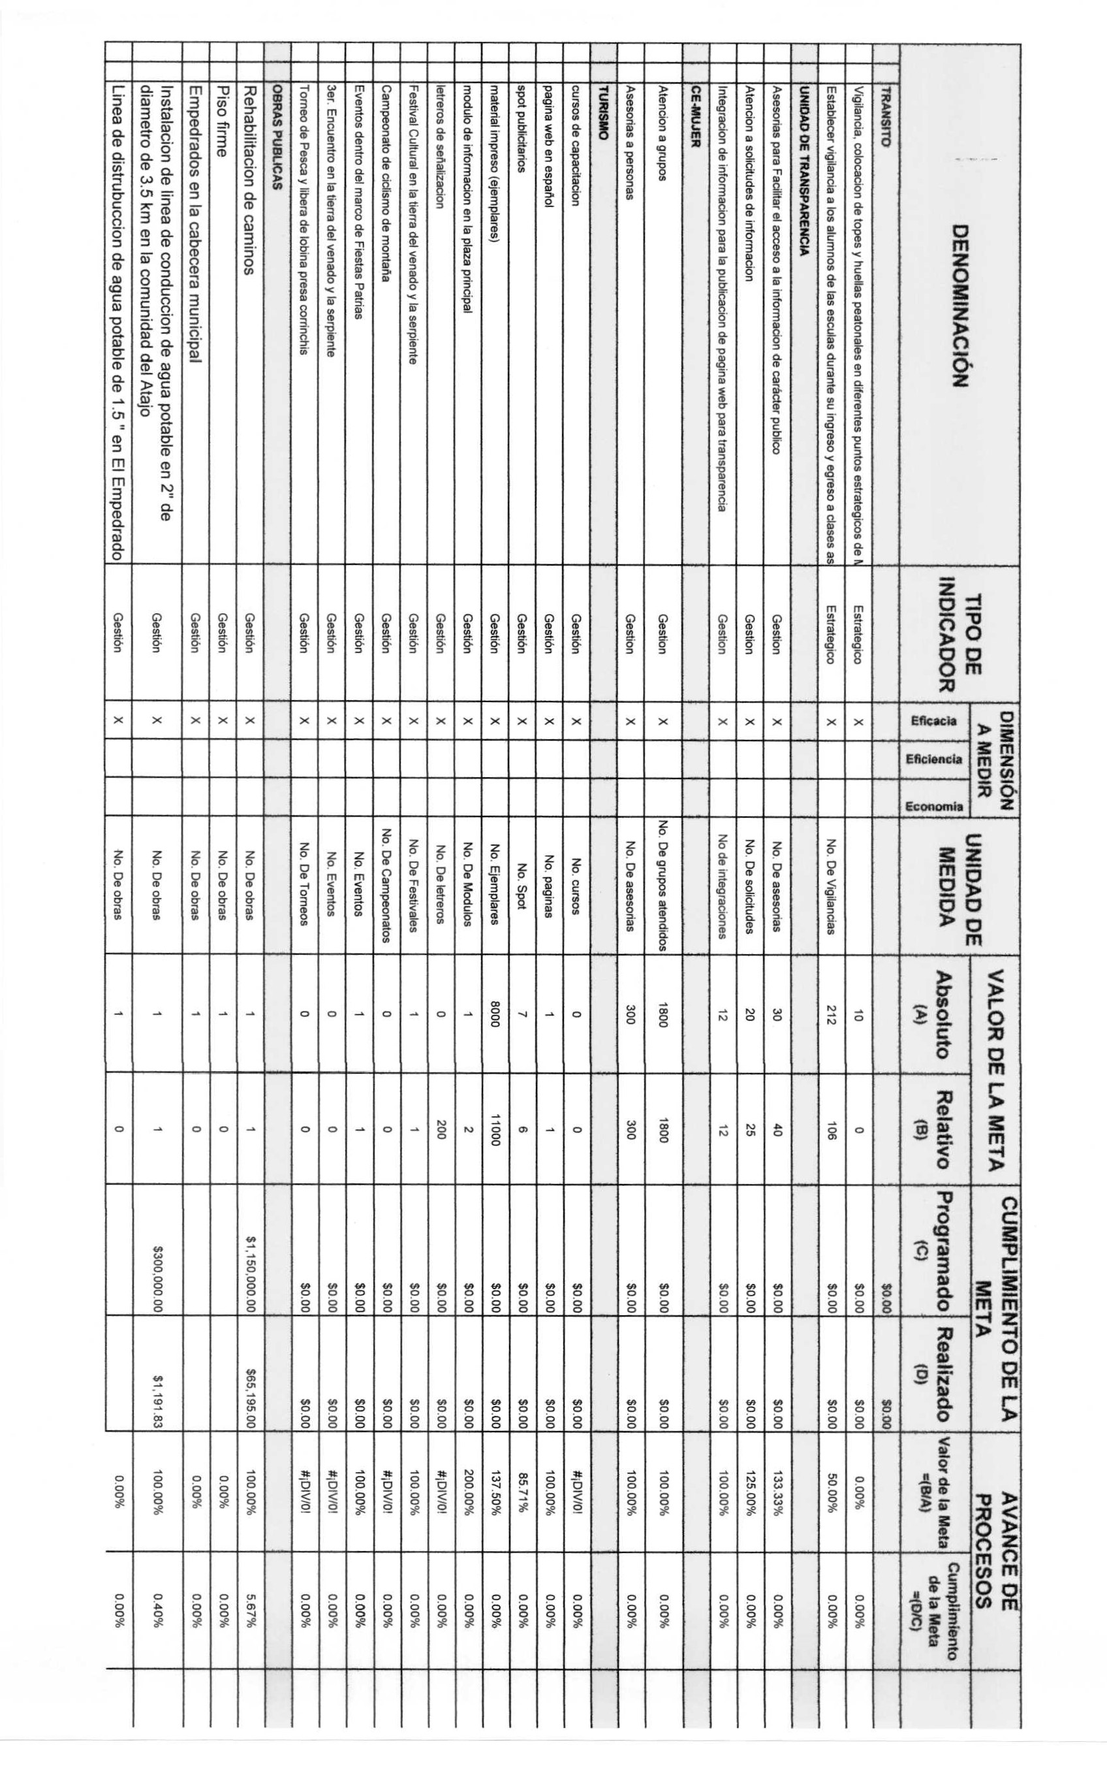
πι m 3 8
α a = α ο α

ΙΙΙΙΙΙΙΙΙΙΙΙΙΙΙΙΙμμ
ιιιιιιιιιιιιιιιιααα=. ιιιιιιιιιιιιιιιιααο— •
ΙΙΙΙΙΙΙΙΙΙΙΙΙΙΙΙΑβΙΙ
ΙΙΙΙΑΙΙΙΑΙΙΙΙΙΙΙΙΙΙΙ

